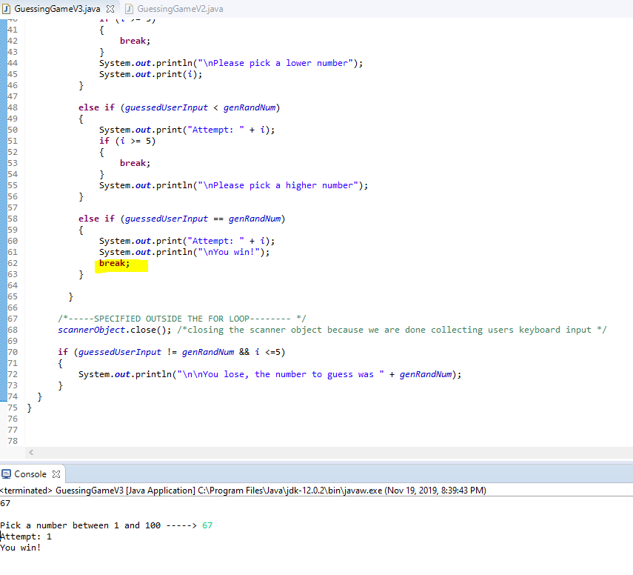

Solved Logic flaw of not continuing the game after the player has won

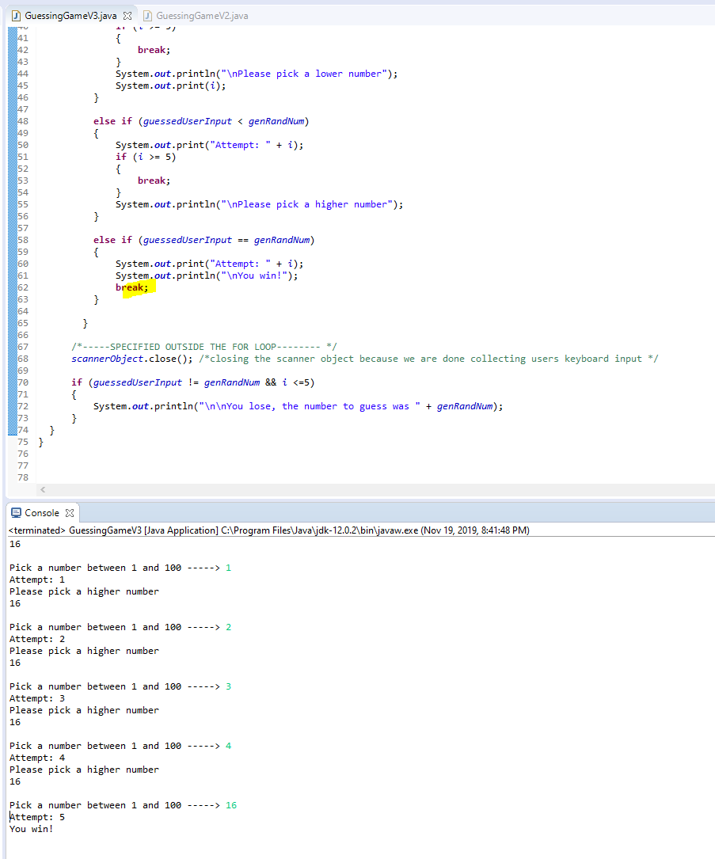

Solved Logic flaw of not having win and then lose statement

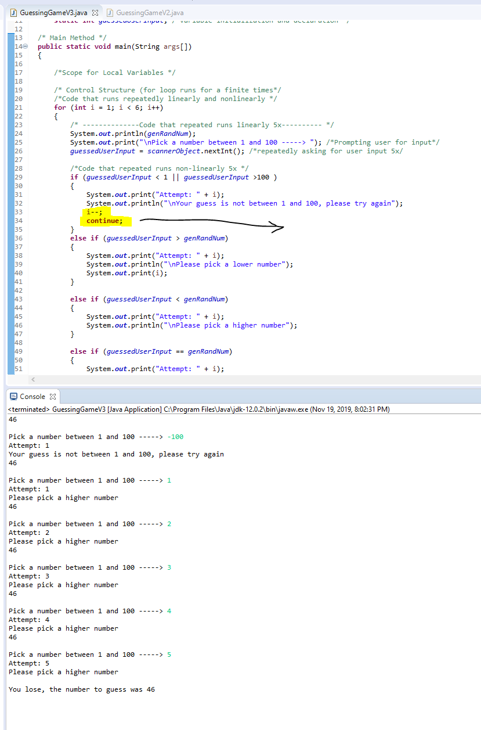

Solved the logic flaw of not taking away an attempt due to the user entering invalid ranges

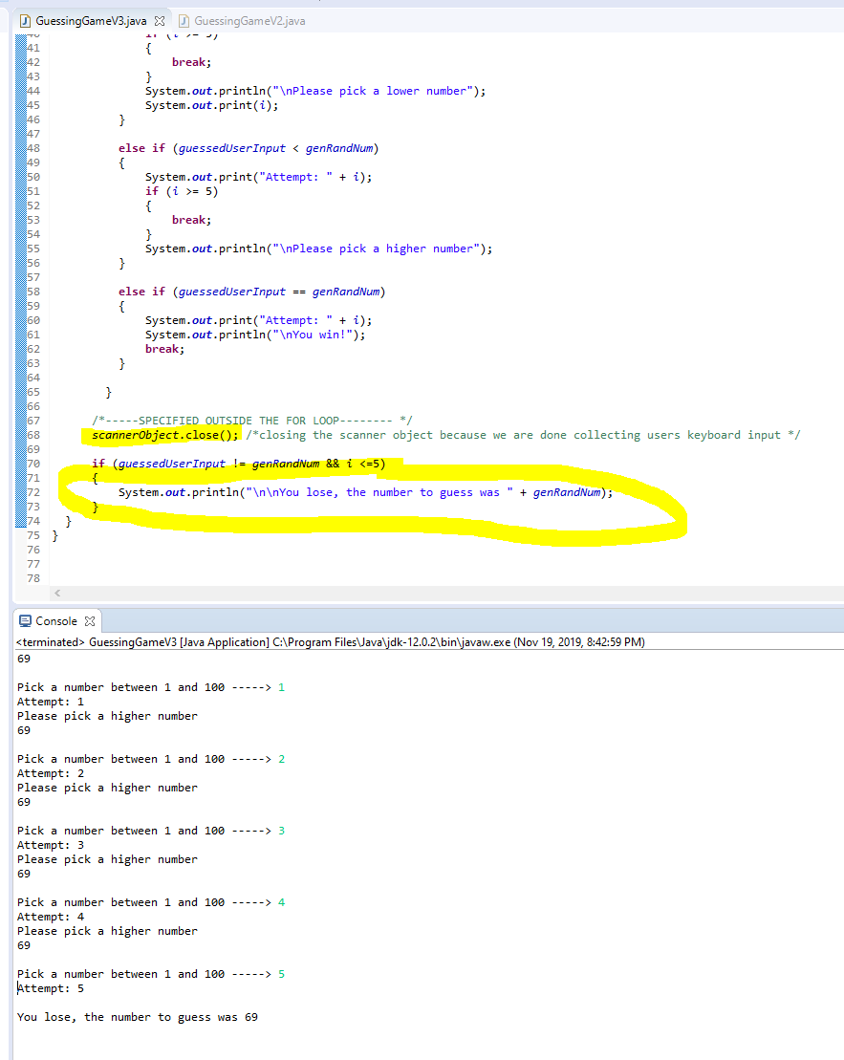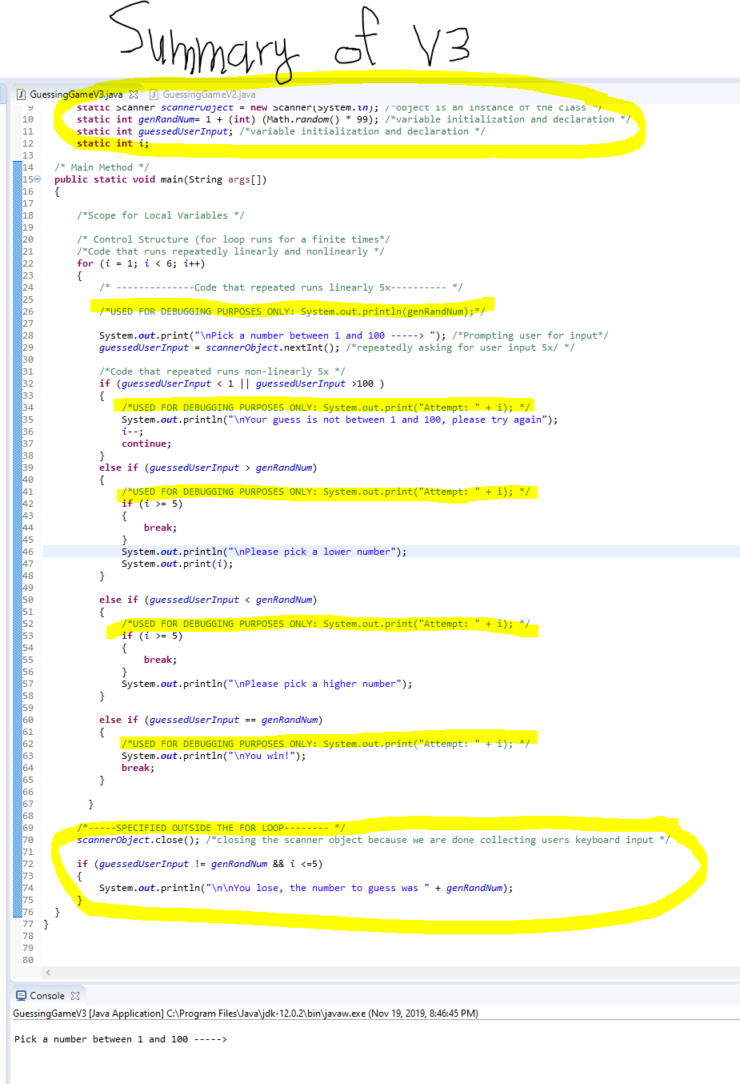

Solved the logic flaw of displaying you lose only after 5 failed attempts